DIP Practicals

1. Write program to read and display digital image using MATLAB or SCILAB

a. Become familiar with SCILAB/MATLAB Basic commands

b. Read and display image in SCILAB/MATLAB

c. Resize given image

d. Convert given color image into gray-scale image

e. Convert given color/gray-scale image into black & white image

f. Draw image profile

g. Separate color image in three R G & B planes

h. Create color image using R, G and B three separate planes

i. Flow control and LOOP in SCILAB

j. Write given 2-D data in image file

*//1.Read and display image in SCILAB/MATLAB*

img=imread("C:\Users\ANUSHKA\Downloads\Dip_Practicals_final\Dip_Practicals\img.jpg")

imshow(img)

*//2.Resize given image*

imga = imresize(img, 1.5);

imgb = imresize(img, 1.5, 'bilinear');

imgc = imresize(img, [100,200], 'bicubic');

figure,imshow(imga)

figure,imshow(imgb)

figure,imshow(imgc)

*//3.Convert given color image into gray-scale image*

img_gray=rgb2gray(img)

figure,imshow(img_gray)

*//4.Convert given color/gray-scale image into black & white image*

img_bw=im2bw(img,0.5)

figure,imshow(img_bw)

*//5.Draw image profile*

improfile(img)

*//6.Separate color image in three R G & B planes*

r = size(img, 1);

c = size(img, 2);

*// creating zero matrices*

R = zeros(r, c, 3);

G = zeros(r, c, 3);

B = zeros(r, c, 3);

*// storing the corresponding color plane*

*// red plane*

R(:, :, 1) = img(:, :, 1);

*// green plane*

G(:, :, 2) = img(:, :, 2);

*// blue plane*

B(:, :, 3) = img(:, :, 3);

*// displaying the images*

figure, imshow(uint8(R));

figure, imshow(uint8(G));

figure, imshow(uint8(B));

*//7.Create color image using R, G and B three separate planes.*

R = img(:, :, 1);

*// green plane*

G = img(:, :, 2);

*// blue plane*

B = img(:, :, 3);

*// Recombine the individual color channels to create the original RGB image again.*

combin= cat(3,R,G,B);

figure,imshow(combin)

*//9.Write given 2-D data in image file*

t=[2,3,4;5,6,7;9,8,2];

matrix_to_image=mat2gray(t)

figure,imshow(image_to_matrix)

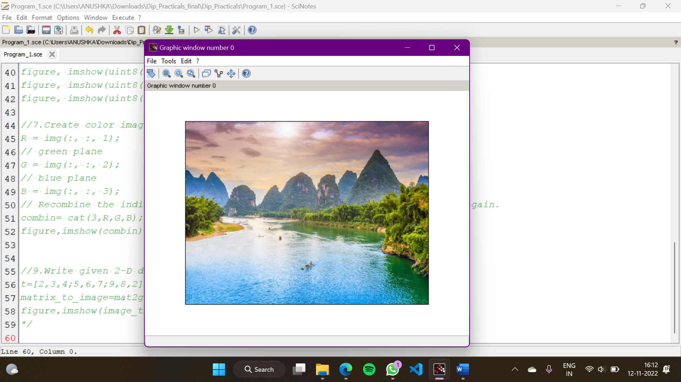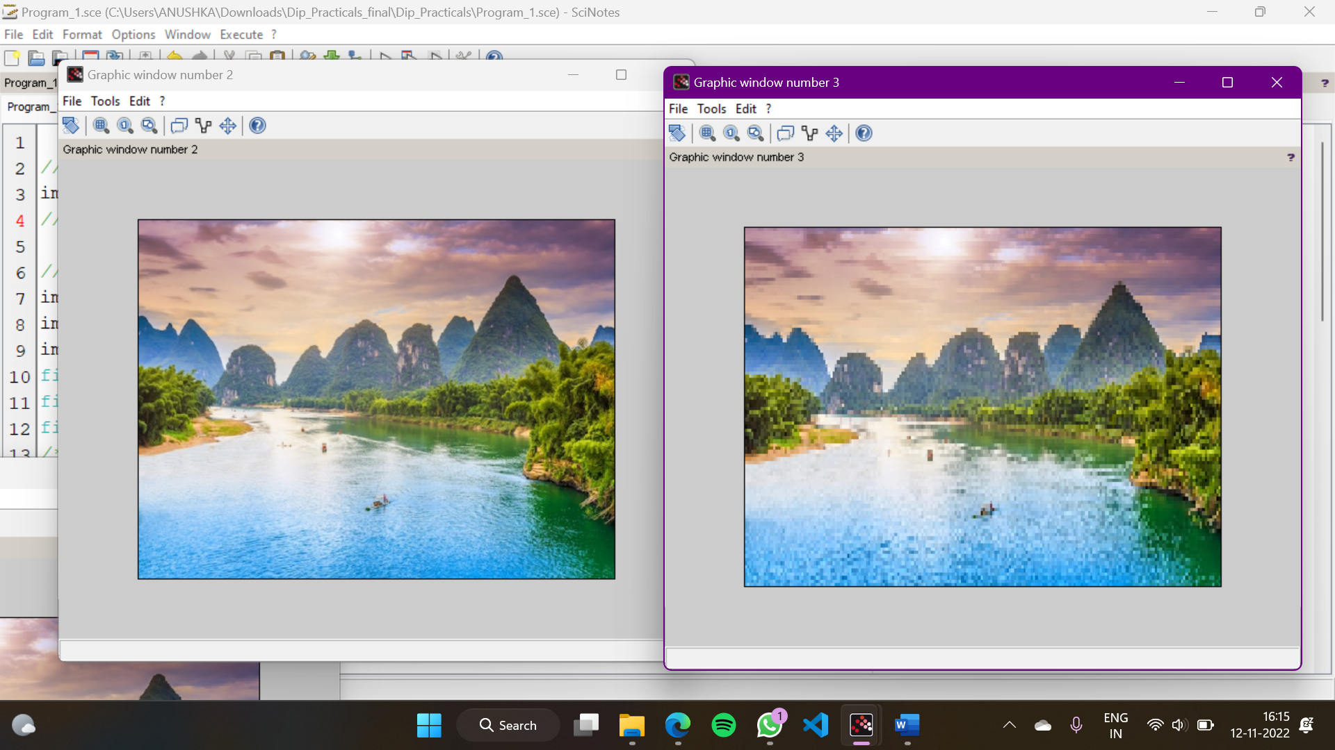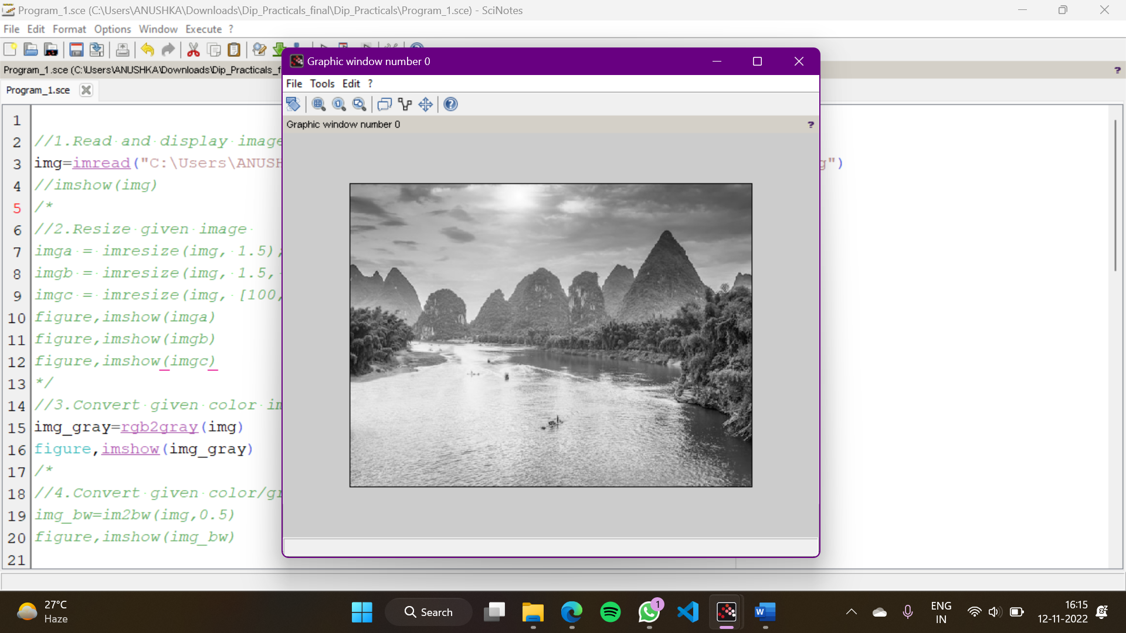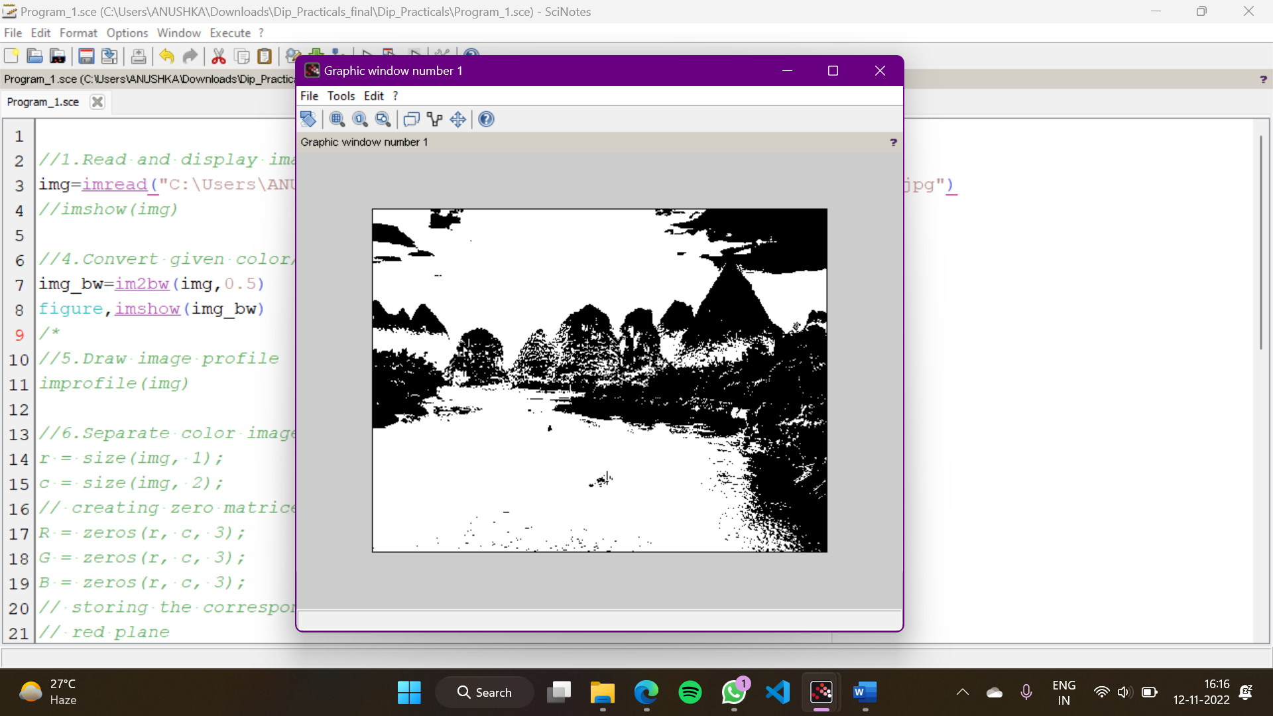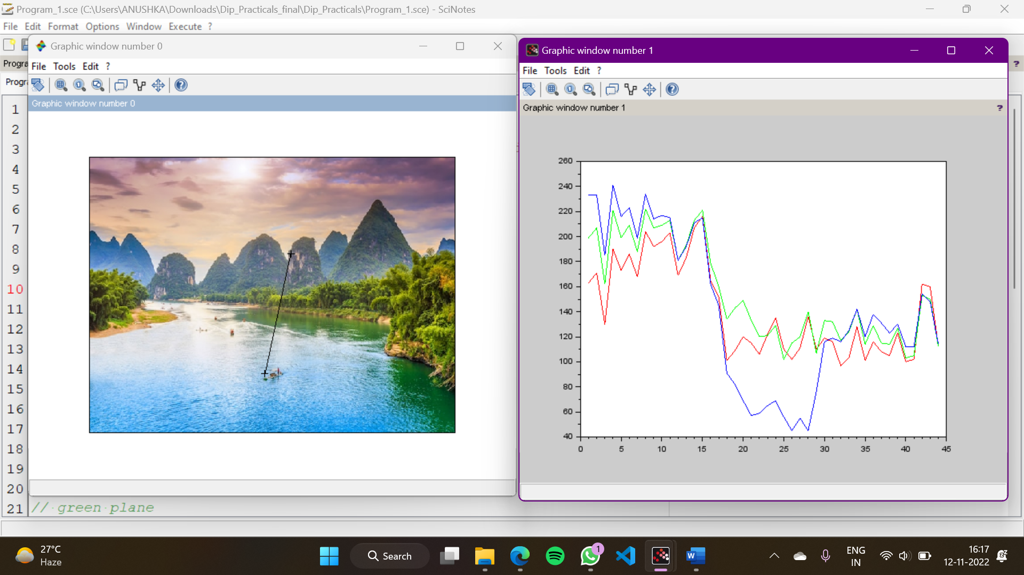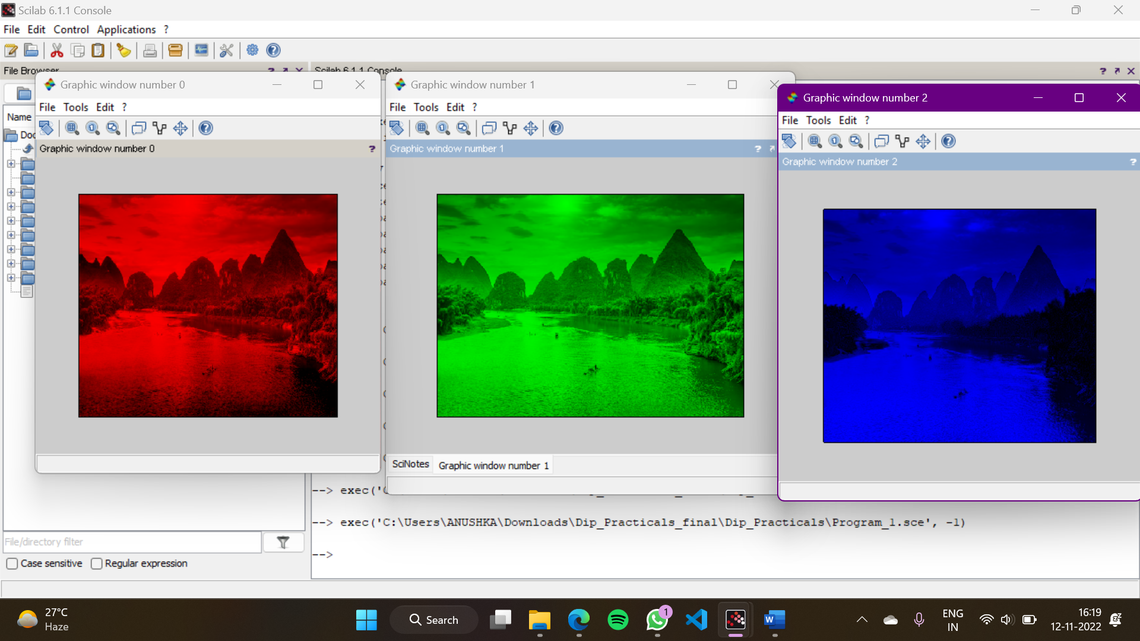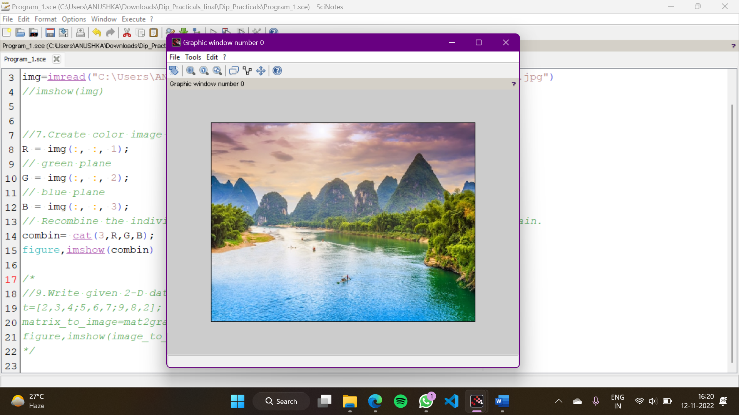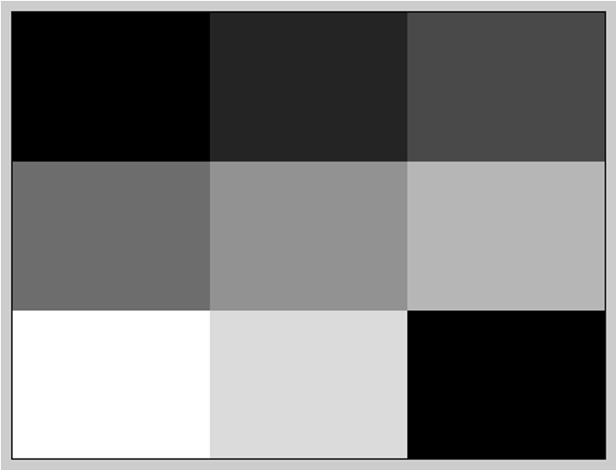

2. To write and execute image processing programs using point processing method

a. Obtain Negative image

b. Obtain Flip image

c. Thresholding

d. Contrast stretching

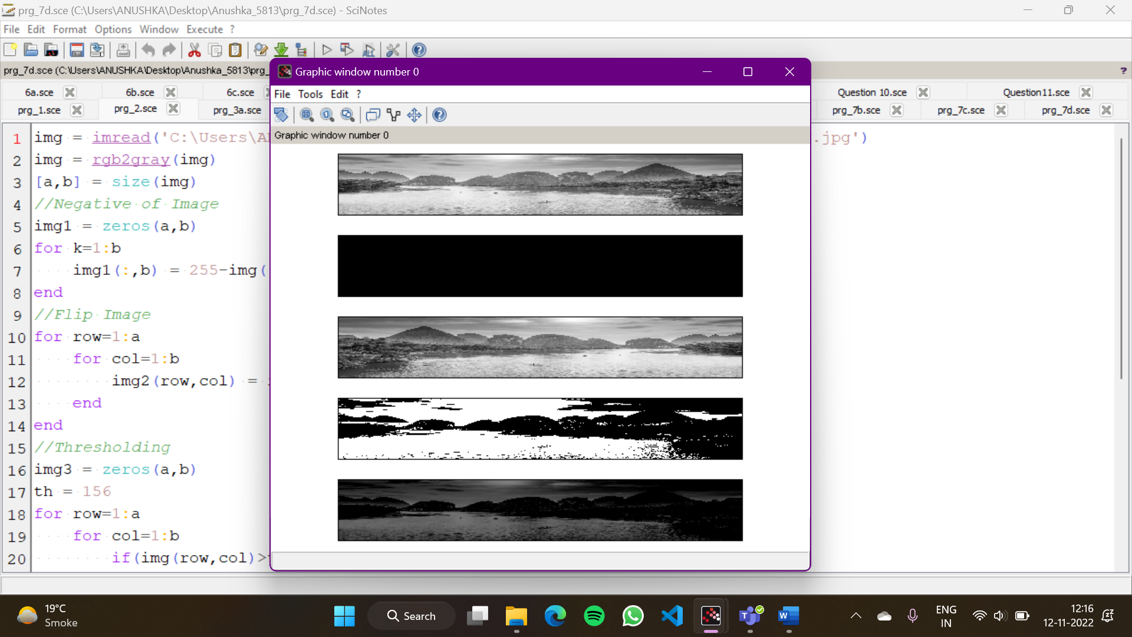

3. To write and execute programs for image arithmetic operations

a. Addition of two images

b. Subtract one image from other image

c. Calculate mean value of image

img1 = imread('C:\Users\ANUSHKA\Downloads\Dip_Practicals_final\Dip_Practicals\img.jpg')

img2 = imread('C:\Users\ANUSHKA\Downloads\Dip_Practicals_final\Dip_Practicals\img1.jpg')

[a,b,c] = size(img1)

img2 = imresize(img2,[a,b]);

imgg1 = double(img1)

imgg2 = double(img2)

*//Add*

img3 = imadd(img2,img1);

for i=1:a

for j=1:b

for k=1:c

img4(i,j,k) = imgg1(i,j,k)+imgg2(i,j,k)

if(img4(i,j,k)>255)

img4(i,j,k)=255

end

end

end

end

subplot(2,2,1);imshow(uint8(img3));

subplot(2,2,2);imshow(uint8(img4));

*//Subtract*

/*img6 = imsubtract(img1,img2);

for i=1:a

for j=1:b

for k=1:c

img5(i,j,k) = imgg1(i,j,k)-imgg2(i,j,k)

if(img5(i,j,k)<0)

img5(i,j,k)=0

end

end

end

end

subplot(2,2,3);imshow(uint8(img5));

subplot(2,2,4);imshow(uint8(img6));

*//Mean*

im1 = rgb2gray(img1);

im2 = double(im1);

x1 = mean2(im1)

theSum = 0.0;

for row = 1 : a

for col = 1 : b

theSum = theSum + im2(row,col);

end

end

x2 = theSum/(a*b);

disp(x1)

disp(x2)*/

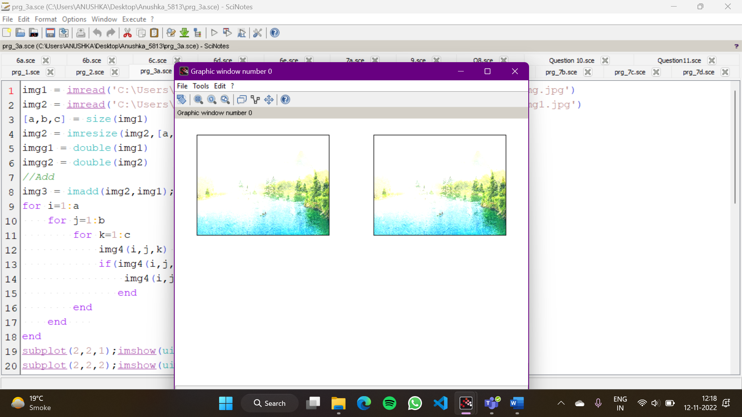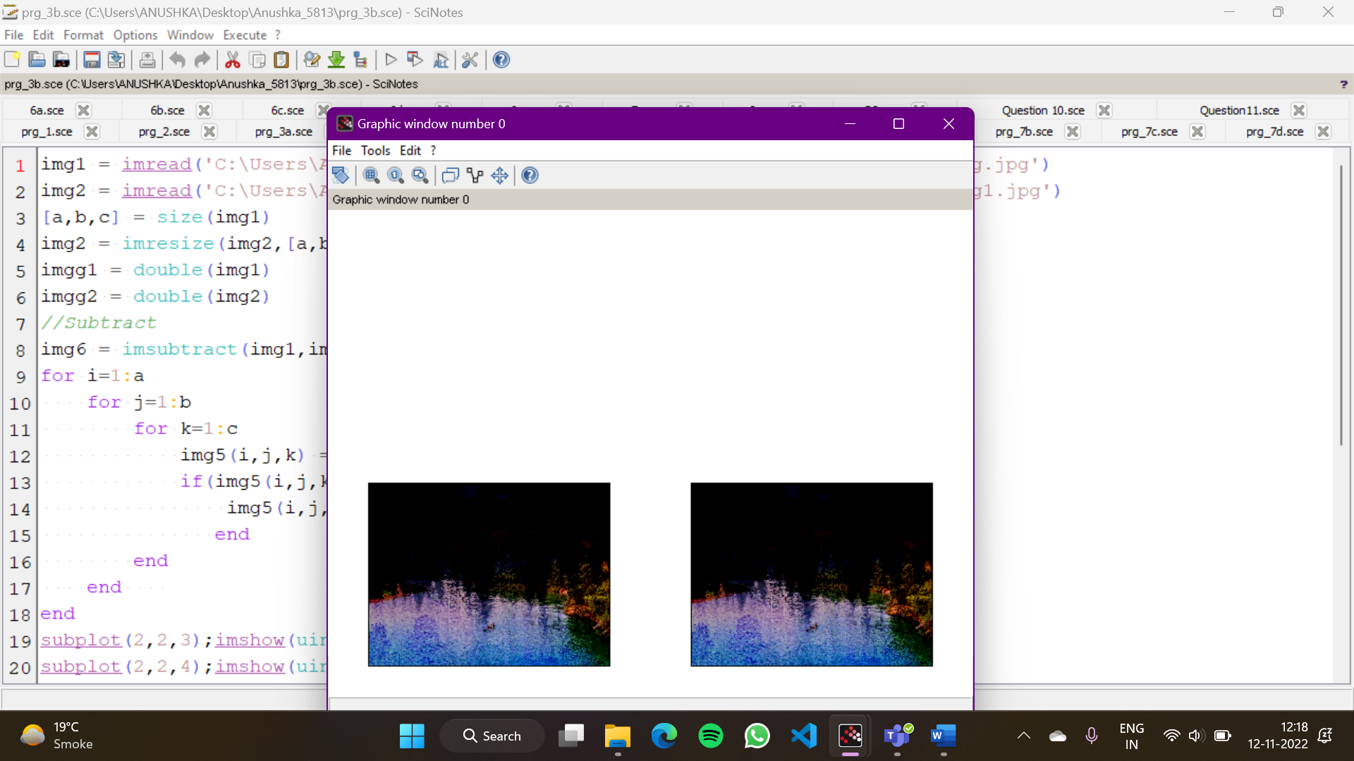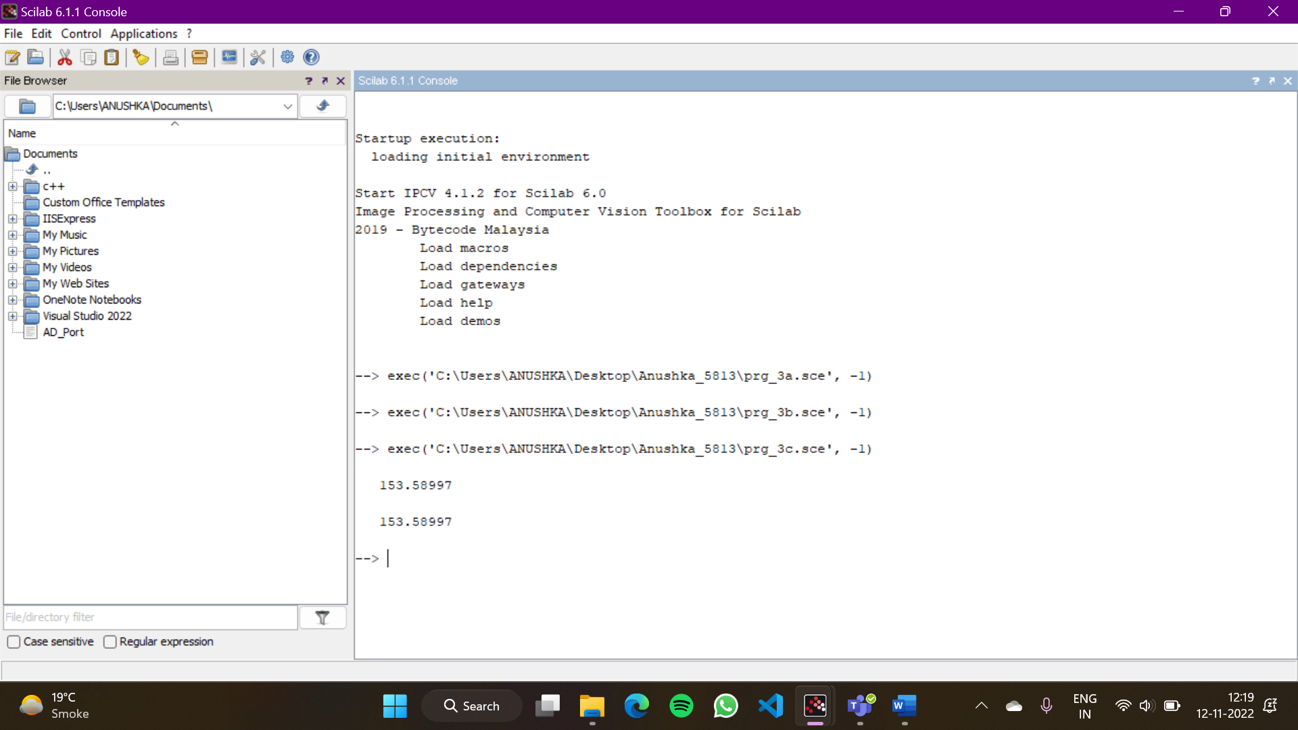

4. To write and execute programs for image logical operations

a. AND operation between two images

b. OR operation between two images

c. Calculate intersection of two images

d. NOT operation (Negative image)

img1 = imread('C:\Users\ANUSHKA\Downloads\Dip_Practicals_final\Dip_Practicals\img.jpg')

img2 = imread('C:\Users\ANUSHKA\Downloads\Dip_Practicals_final\Dip_Practicals\img1.jpg')

img1=im2bw(img1,0.5);

img2=im2bw(img2,0.5);

[a b]=size(img1);

img2=imresize(img2,[a b]);

for i=1:b

result=img1(:,i)&img2(:,i);

end

subplot(3,2,1),imshow(img1),title("Original Image 1");

subplot(3,2,2),imshow(img2),title("Original Image 2");

subplot(3,2,3),imshow(result),title("Images after AND-Operation");

for i=1:b

result=img1(:,i)|img2(:,i);

end

subplot(3,2,4),imshow(result),title("Images after OR-Operation");

for i=1:b

result=~(~(img1(:,i))|~(img2(:,i)));

end

subplot(3,2,5),imshow(result),title("Images after Intersection-Operation");

for i=1:b

result=~(img1(:,i));

end

disp(result);

subplot(3,2,6),imshow(result),title("Images after NOT-Operation");

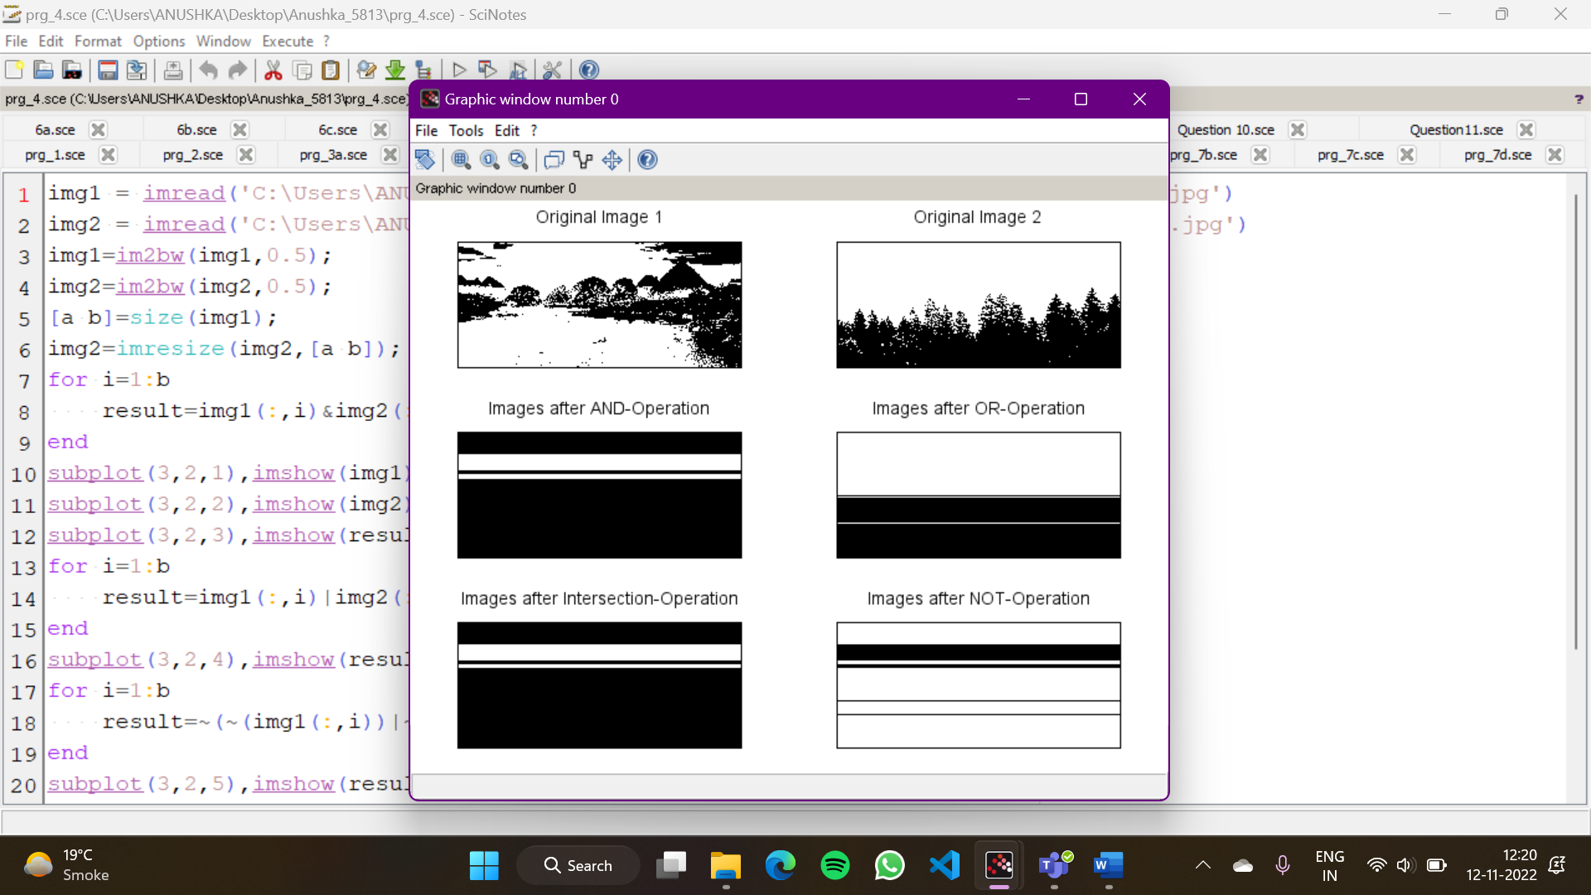

5. To write a program for histogram calculation and equalization using

a. Standard MATLAB function

b. Program without using standard MATLAB functions

img = imread('C:\Users\ANUSHKA\Downloads\Dip_Practicals_final\Dip_Practicals\img.jpg')

im = rgb2gray(img);

scf(1);

imhist(im, 256, 0.5);

new_img = imhistequal(im) ;

scf(0);

imhist(new_img, 256, 0.5, 'green') ;

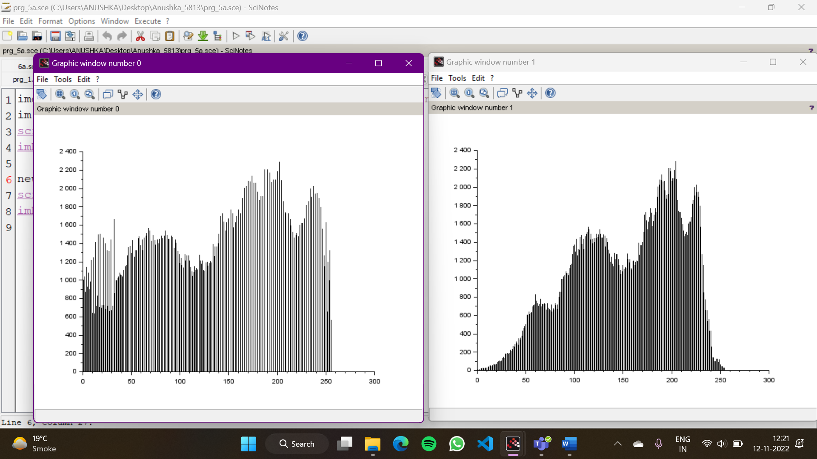

img = imread('C:\Users\ANUSHKA\Downloads\Dip_Practicals_final\Dip_Practicals\img.jpg')

im = rgb2gray(img);

frequency = zeros(1, 256) ;

*//creating frequency array*

for i=1:a

for j=1:b

frequency(im(i, j) + 1) = frequency(im(i,j) + 1) + 1 ;

end

end

*//finding probability*

prob = zeros(1, 256) ;

for i=1:256

prob(i) = frequency(i)/(a*b) ;

end

*//cumulative freq calculation*

cum_freq_prob = zeros(1, 256) ;

cum_freq_prob = prob(1) ;

for i=2:256

cum_freq_prob(i) = cum_freq_prob(i-1) + prob(i) ;

end

equalized = zeros(1, 256) ;

*//rounding off cumulative freq*

for i=1:256

equalized(i) = round(255*cum_freq_prob(i)) ;

end

*//normalization*

normalized = zeros(1, 256)

i = 1 ;

j = 1 ;

*//displaying equalization values*

disp(equalized)

while j<= 256 && i<=256

if equalized(i) == equalized(j) then

normalized(equalized(i) + 1) = normalized(equalized(i) + 1) + frequency(j) ;

j = j+1 ;

else

i = j ;

end

end

*//displaying normlaized values after histogram equalization*

disp(normalized)

scf(3) ; bar(normalized)

scf(4) ; bar(frequency)

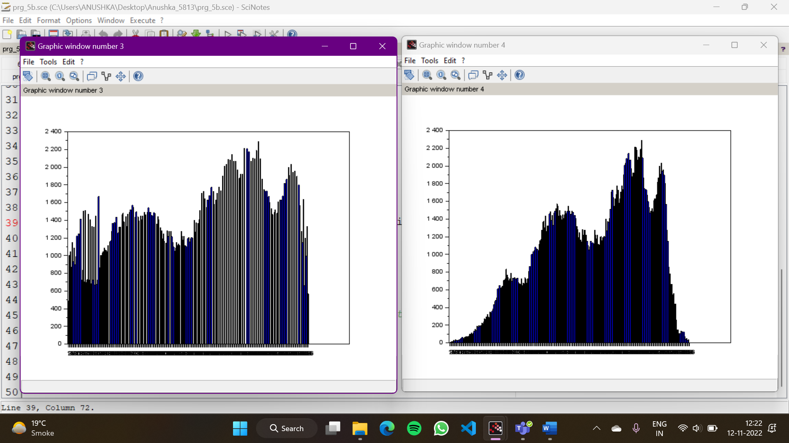

6. To write and execute program for geometric transformation of image

a. Translation

b. Scaling

c. Rotation

d. Shrinking

e. Zooming

img = imread('C:\Users\ANUSHKA\Downloads\Dip_Practicals_final\Dip_Practicals\img.jpg');

img1 = rgb2gray(img);

[a,b] = size(img1);

subplot(2,2, 1), imshow(uint8(img)),title("Original Image");

*//Translation*

mat2 = [1 0 0;0 1 0;40 0 1]

transl = imtransform(img1,mat2,'affine');

subplot(2,2, 4), imshow(uint8(transl), title("Translation"));

*//Scaling*

mat1 = [2 0 0;0 2 0;0 0 1]

scale = imtransform(img1,mat1,'affine');

subplot(2,2, 3), imshow(uint8(scale));

*//Rotation*

mat = [cosd(30) -sind(30) 0;sind(30) cosd(30) 0;0 0 1]

rotation = imtransform(img1,mat,'affine');

subplot(6,1, 2), imshow(uint8(rotation), title("Rotation"))

*//Shrinking*

c = a/2

d = b/2

new_img = zeros(c, d)

x = 1

y = 1

for i=1:c

for j=1:d

new_img(i, j) = im(x, y)

y = y + 2

end

y = 1

x = x + 2

end

subplot(6,1, 6), imshow(uint8(new_img)),title("Shrinking")

*//Zooming*

for i=1:2*m

for j=1:2*n

a=i-floor(i/2);

b=j-floor(j/2);

new_img_2(i, j) = img1(a,b);

end

end

figure, imshow(uint8(new_img_2)),title("Zooming")

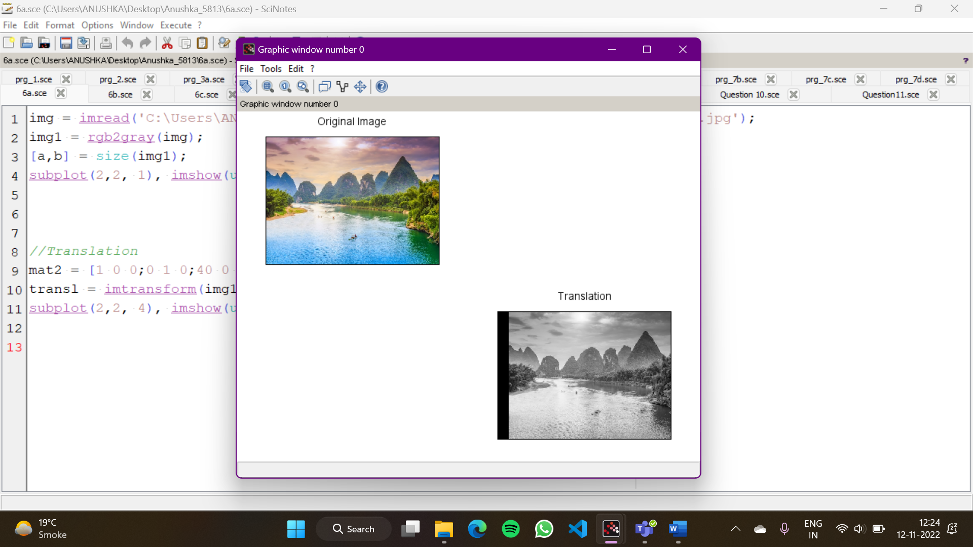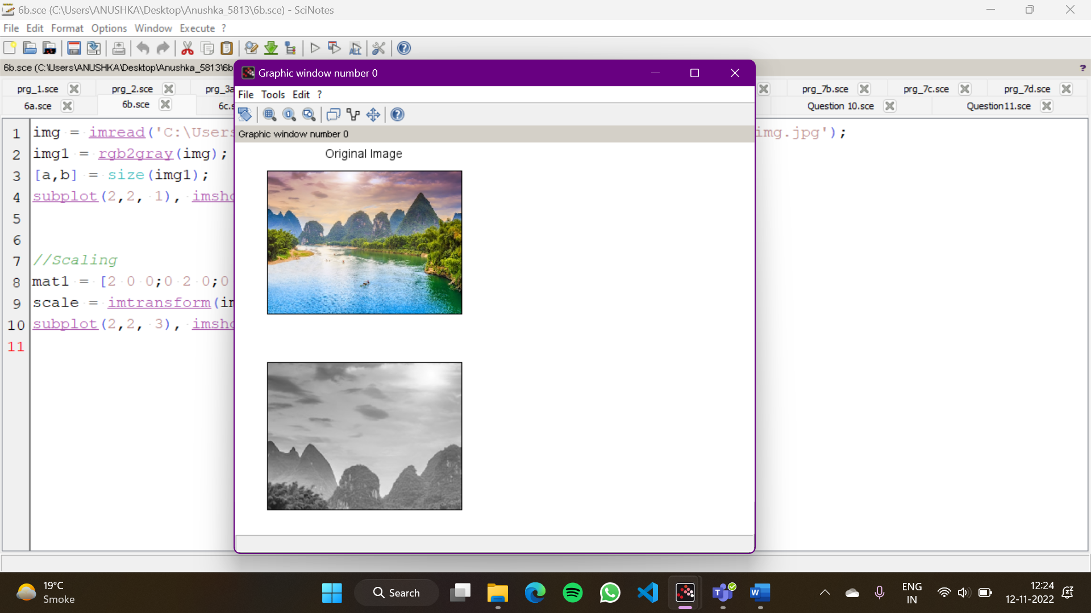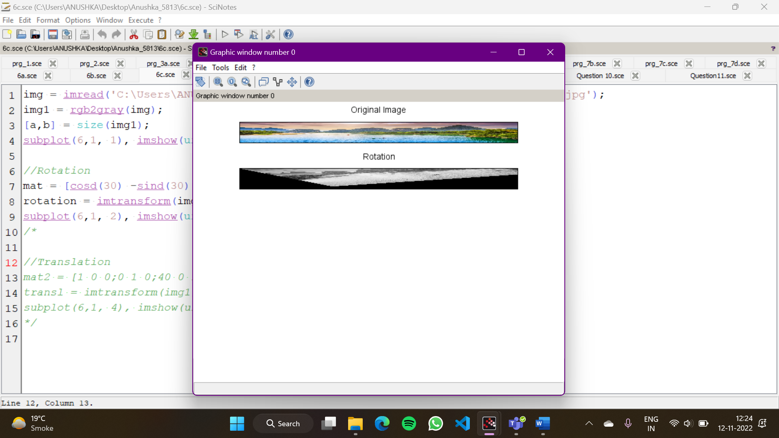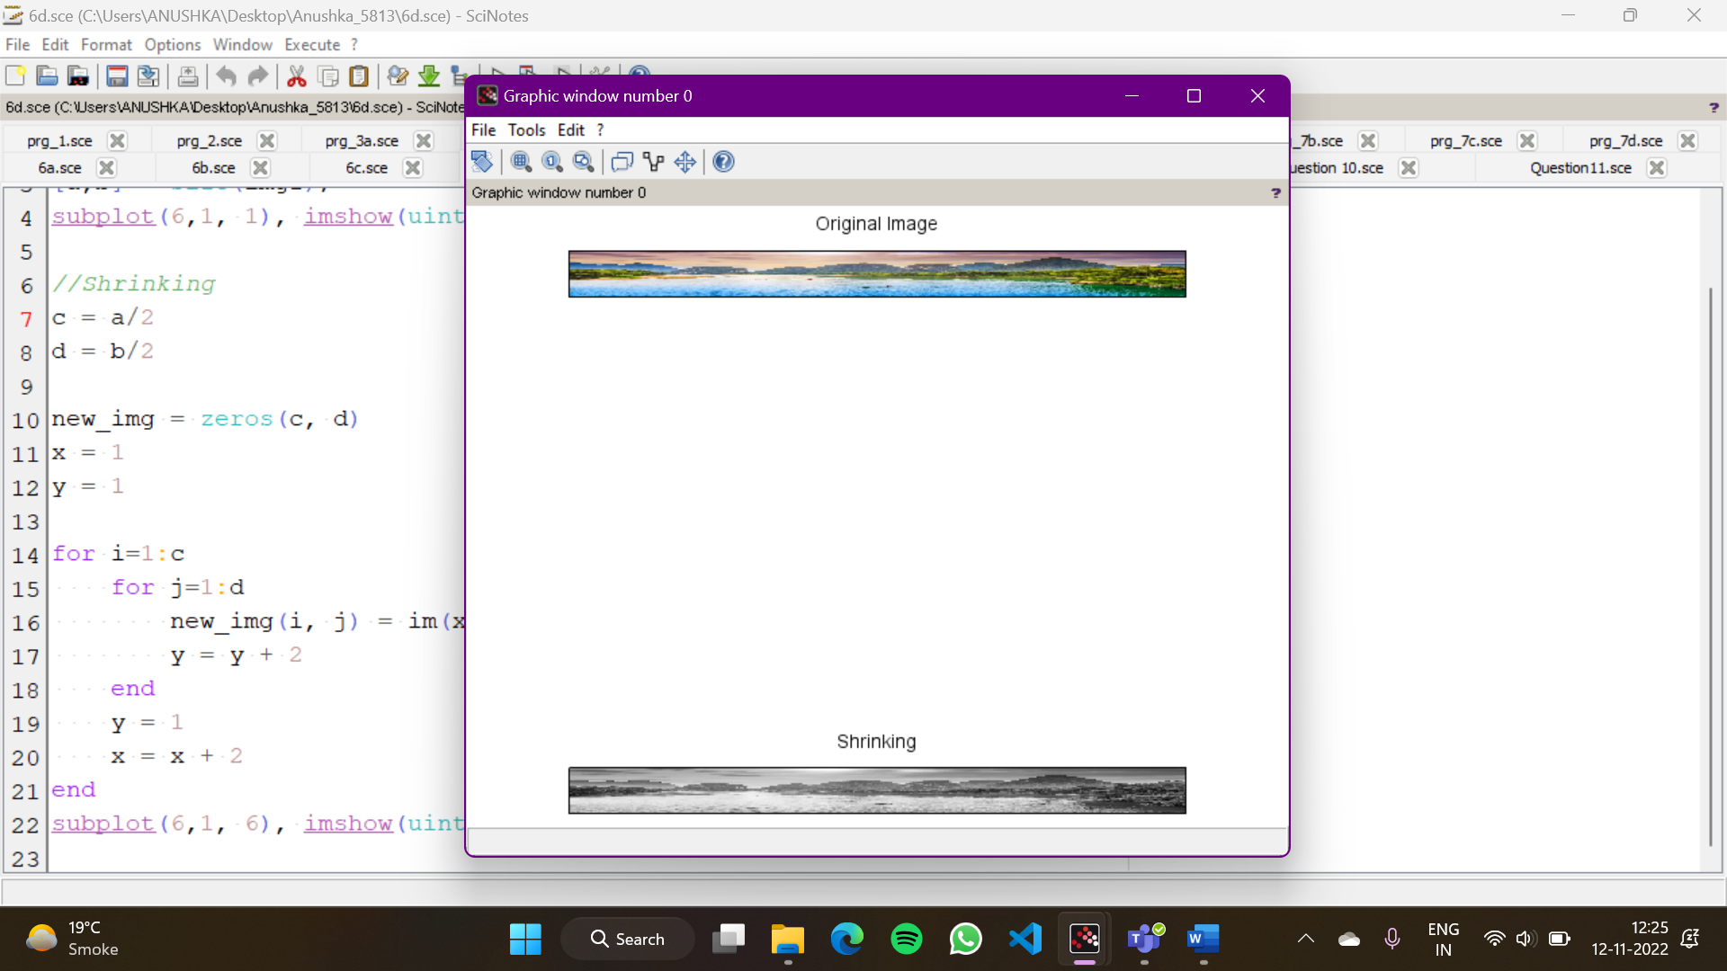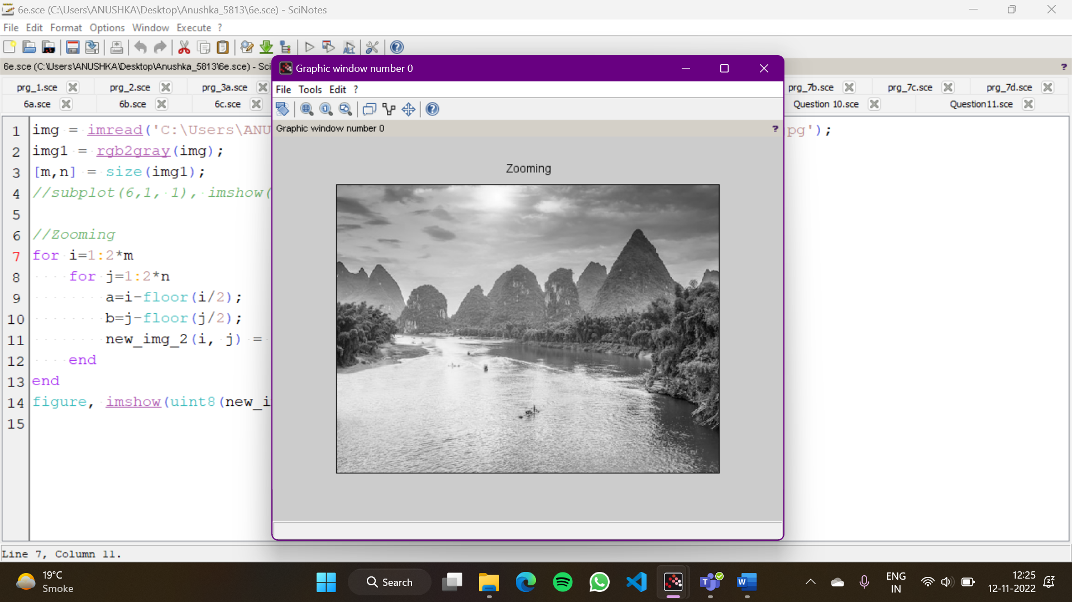

7. To understand various image noise models and to write programs for

a. image restoration

b. Remove Salt and Pepper Noise

c. Minimize Gaussian noise

d. Median filter

im = imread(fullpath(getIPCVpath() + "/images/baboon.png"));

subplot(3,2,1);imshow(im) ;

imn = imnoise(im, 'salt & pepper');

subplot(3,2,2);imshow(imn);

filter = fspecial('gaussian');

imf = imfilter(imn, filter);

subplot(3,2,3);imshow(imf);

filter = fspecial('laplacian') ;

imf1 = imfilter(imn, filter) ;

subplot(3,2,4) ; imshow(imf1) ;

filter = fspecial('sobel') ;

imf2 = imfilter(imn, filter) ;

subplot(3,2,5) ; imshow(imf2) ;

imf3 = immedian(imn,3) ;

subplot(3,2,6) ; imshow(imf3) ;

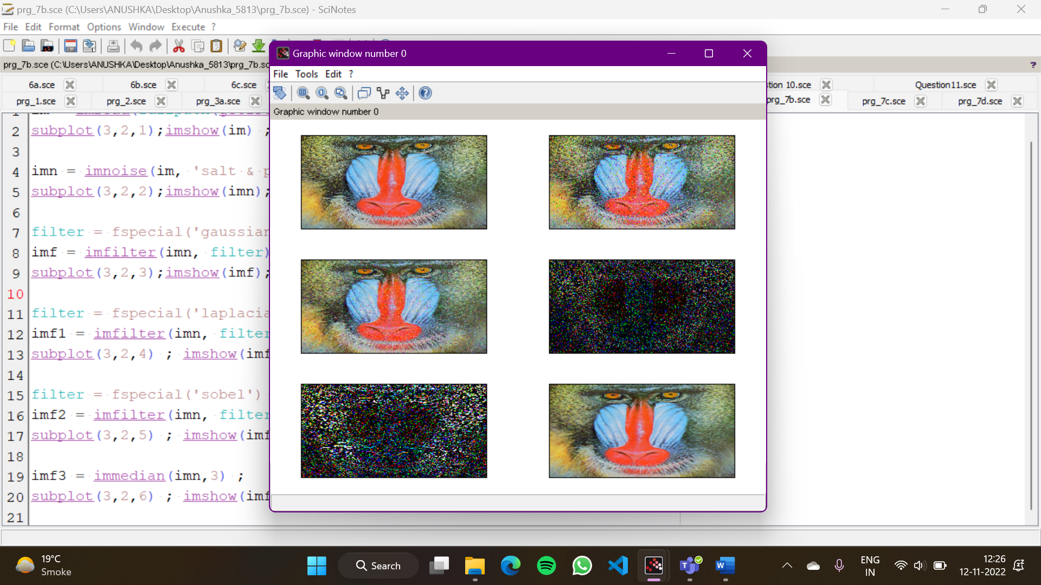

im = imread(fullpath(getIPCVpath() + "/images/baboon.png"));

subplot(3,2,1);imshow(im) ;

imn = imnoise(im, 'gaussian');

subplot(3,2,2);imshow(imn);

filter = fspecial('gaussian');

imf = imfilter(imn, filter);

subplot(3,2,3);imshow(imf);

filter = fspecial('laplacian') ;

imf1 = imfilter(imn, filter) ;

subplot(3,2,4) ; imshow(imf1) ;

filter = fspecial('sobel') ;

imf2 = imfilter(imn, filter) ;

subplot(3,2,5) ; imshow(imf2) ;

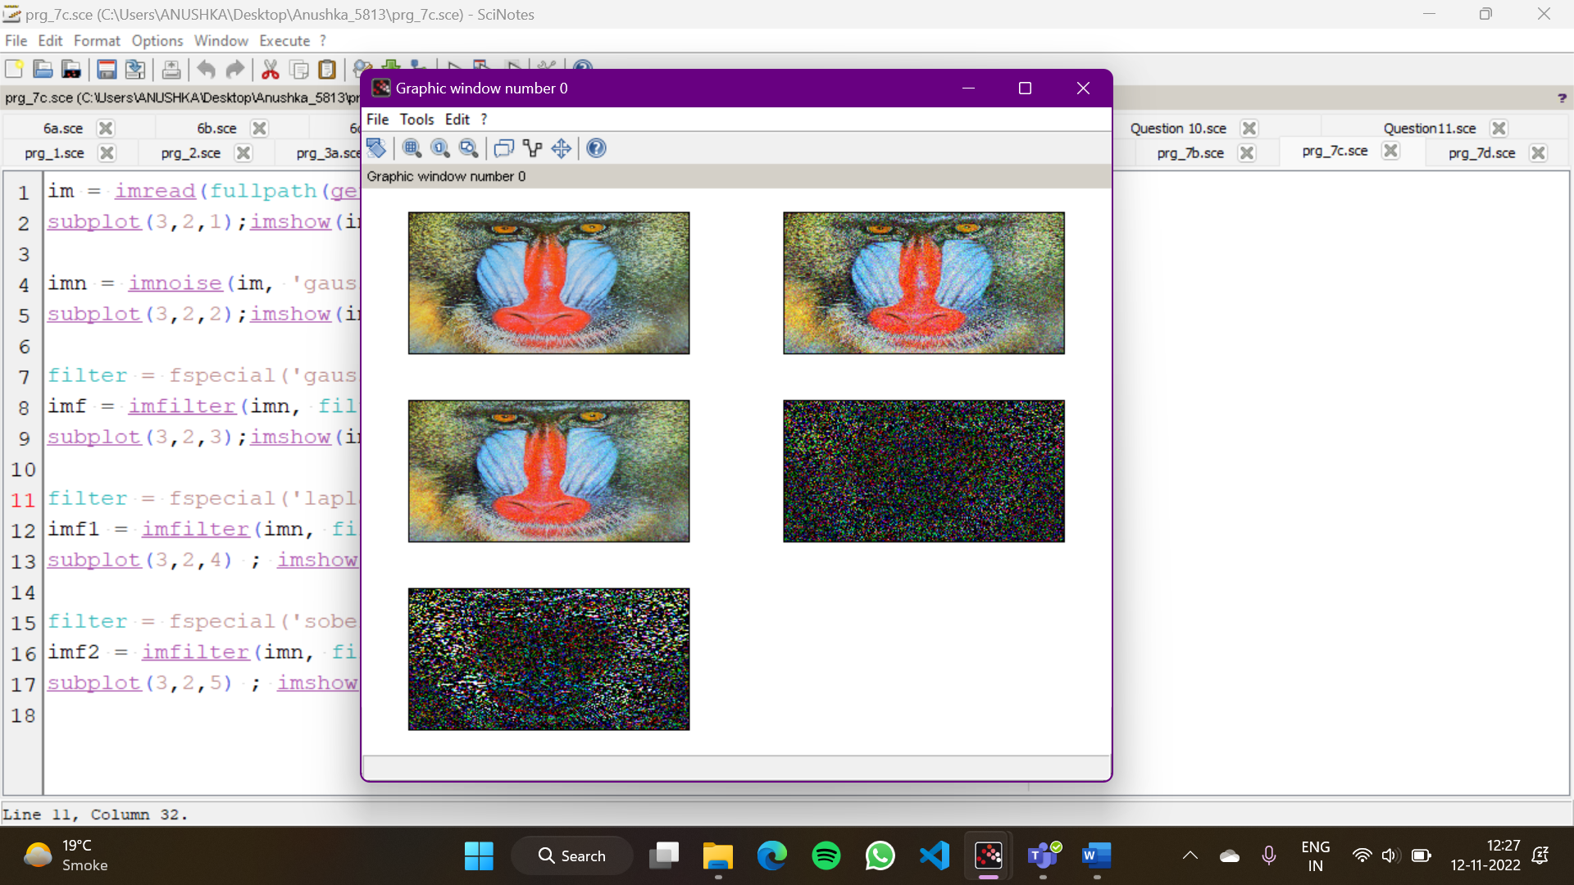

image = imread('C:\Users\ANUSHKA\Downloads\Dip_Practicals_final\Dip_Practicals\img.jpg');

img = rgb2gray(image);

subplot(2,2,1);

imshow(img);

title('Original image');

j = imnoise(img, 'salt & pepper');

*//removing noise*

Kmedian = immedian(j, 3);

*//Median filter*

subplot(2,2, 2);

imshow(Kmedian);

title('Image after applying median filter');

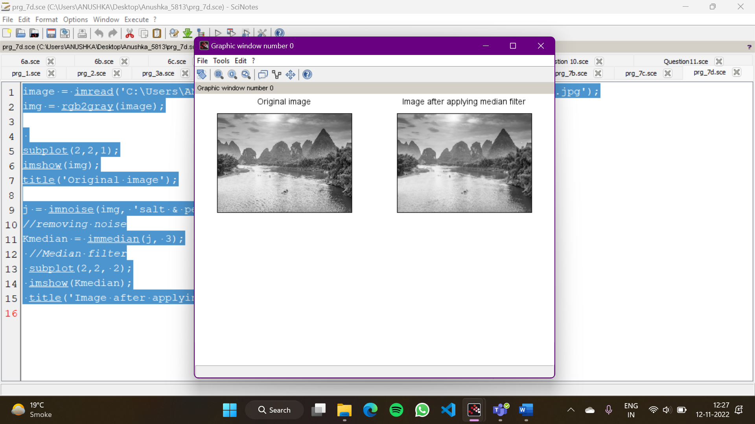

8. Write and execute programs to use spatial low pass and high pass filters

img = imread('C:\Users\ANUSHKA\Downloads\Dip_Practicals_final\Dip_Practicals\img.jpg')

subplot(3,2,1),imshow(img),title("Original Image");

img=imnoise(img,'salt & pepper');

subplot(3,2,2),imshow(img),title("Image with salt and pepper noise");

filter = fspecial('average');

imf1 = imfilter(img, filter);

subplot(3,2,3),imshow(imf1),title("Image after filtering with averaging filter");

filter = fspecial('sobel');

imf2 = imfilter(img, filter);

subplot(3,2,4),imshow(imf2),title("Image after filtering with sobel filter");

filter = fspecial('gaussian');

imf3 = imfilter(img, filter);

subplot(3,2,5),imshow(imf3),title("Image after filtering with gaussian filter");

filter = fspecial('laplacian');

imf4 = imfilter(img, filter);

subplot(3,2,6),imshow(imf4),title("Image after filtering with laplacian filter");

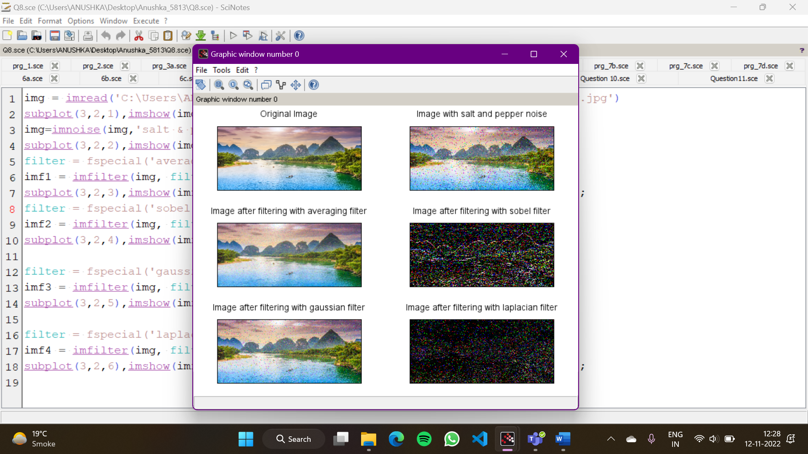

9. Write and execute programs for image frequency domain filtering

a. Apply FFT on given image

b. Perform low pass and high pass filtering in frequency domain

c. Apply IFFT to reconstruct image

img = imread('C:\Users\ANUSHKA\Downloads\Dip_Practicals_final\Dip_Practicals\img.jpg')

img2 = rgb2gray(img)

S = img2;

P=img2;

h = mkfftfilter(S,'gauss',0.1);

i = mkfftfilter(S,'butterworth1',0.1);

S2 = fft2(im2double(S));

P2 = fft2(im2double(P));

S3 = S2.*fftshift(1-h);

P3 = P2.*fftshift(1-h);

S4 = real(ifft(S3));

P4 = real(ifft(P3));

subplot(3,2,1);

xtitle('original image')

imshow(S);

subplot(3,2,2);

xtitle('image in frequency domain')

imshow(S2);

subplot(3,2,3);

xtitle('gaussian filter')

imshow(1-h);

subplot(3,2,4);

xtitle('butterworth filter')

imshow(1-i);

subplot(3,2,5);

xtitle('image after inverse fourier transform')

imshow(S4);

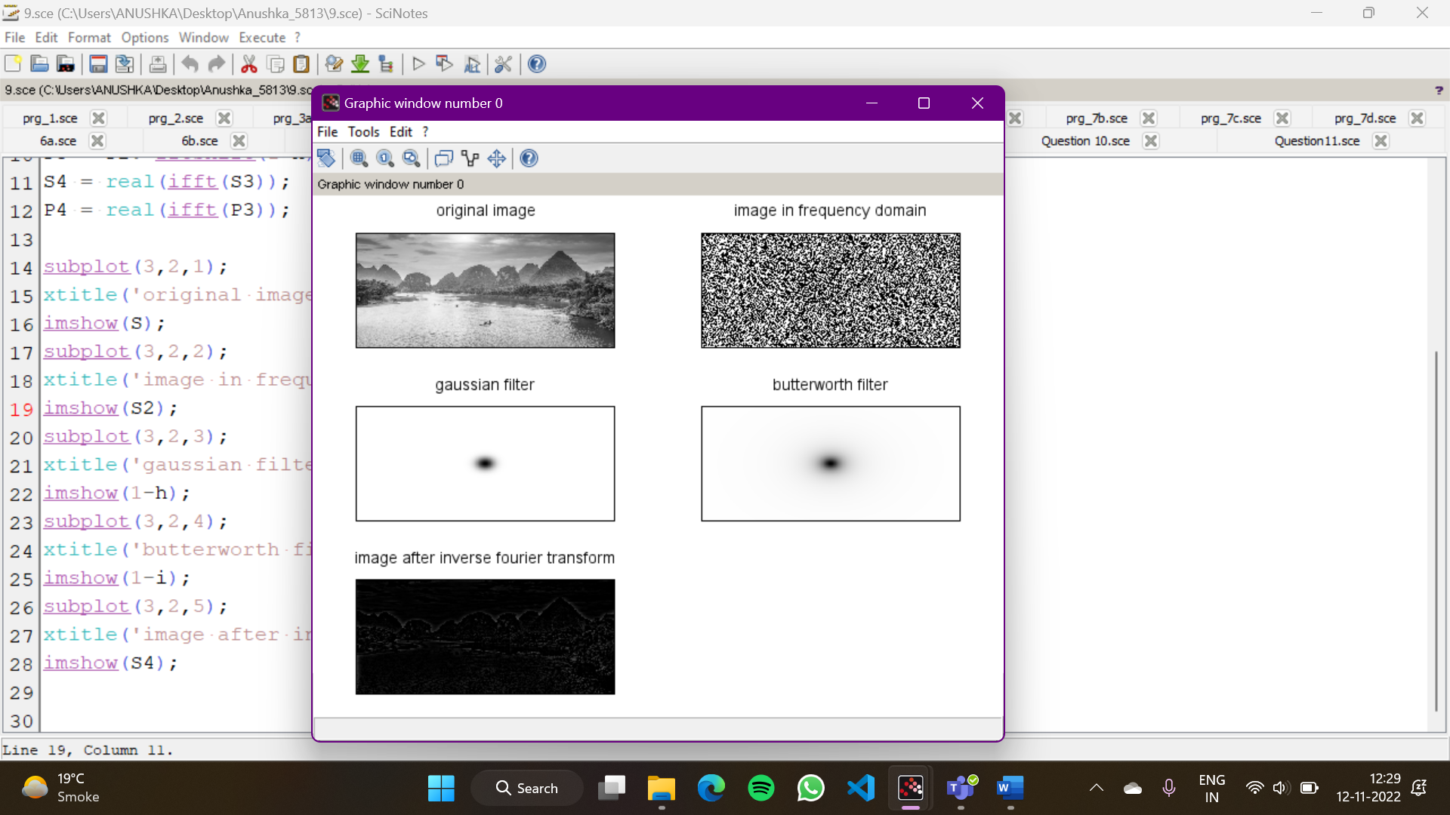

10. Write a program in C and MATLAB/SCILAB for edge detection using different edge

detection mask

img =imread('C:\Users\ANUSHKA\Downloads\Dip_Practicals_final\Dip_Practicals\img.jpg');

img = rgb2gray(img);

f = fspecial('sobel');

f1 = fspecial('laplacian');

f2 = fspecial('prewitt');

b = imfilter(img,f);

c = imfilter(img,f1);

d = imfilter(img,f2);

subplot(1,3,1),imshow(b),title('Sobel Filter');

subplot(1,3,2),imshow(c),title('Laplacian filter');

subplot(1,3,3),imshow(c),title('Prewitt filter');

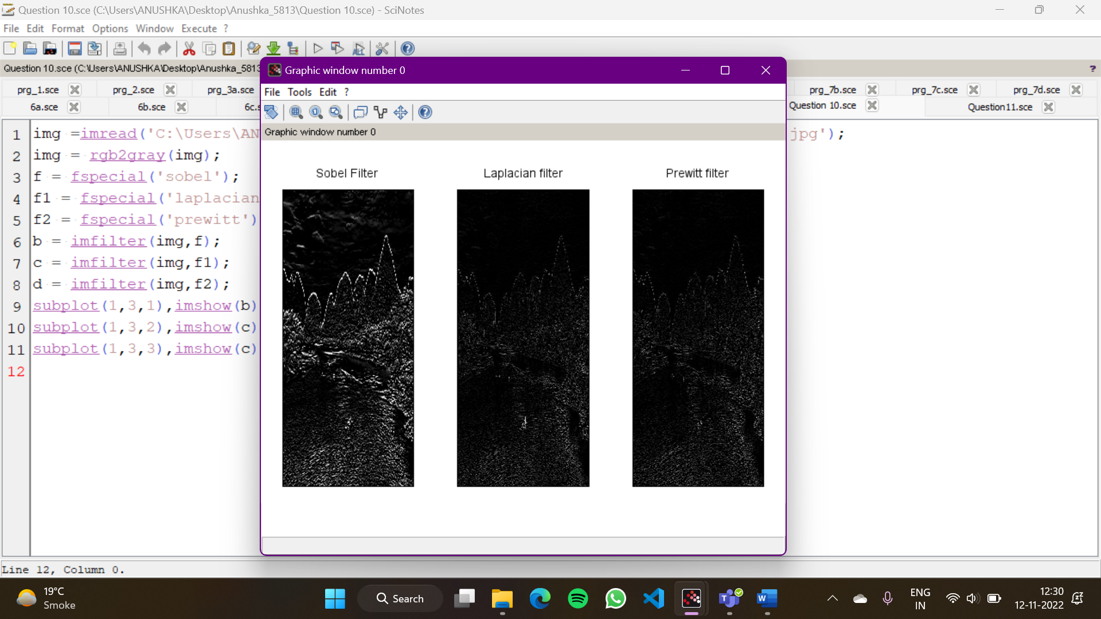

11. Write and execute program for image morphological operations erosion and dilation.

img = imread('C:\Users\ANUSHKA\Downloads\Dip_Practicals_final\Dip_Practicals\img.jpg')

im = im2bw(img,0.5);

se = imcreatese('rect',3,3);

a = imerode(im,se);

b = imdilate(im,se);

subplot(2,2,1),imshow(img),title('Original Image');

subplot(2,2,2),imshow(im),title('Original Image');

subplot(2,2,3),imshow(a),title('Eroded Image');

subplot(2,2,4),imshow(b),title('Dialated Image');

